
SAILING DAYS

Sailing Days are being run by the Docklands Yacht Club which, as members of Banyule District Scouts, you are welcome to attend on
Sunday November 13th and/or Sunday November 27th.

Location is Docklands Sailing Club (see map over page)

Time: 11am to 4pm on either day

Cost is $10 per person or $20 a family (parents to supervise children for the day). Everybody can go sailing.

Bring:
- If sailing you need boat shoes or runners (no open sandals or crocs)
- Bring warm gear as the wind may be chilly.
- Bring a change of clothes as you may get wet.
- Cubs to wear their Cub scarf on arrival.
- Lunch/Drinks
- Sunscreen/Hat

The yachts we will be using are “untippable” in the conditions we will be sailing in.

You may earn your Green Level Sailing Badge

Please report to Jan Bryar (our District Cub Leader) and/or other Leaders present on arrival.

Regards

Akela (Wayne)
0411 121 495
akela@rosannacubs.org
see us at www.rosannacubs.org

...PTO
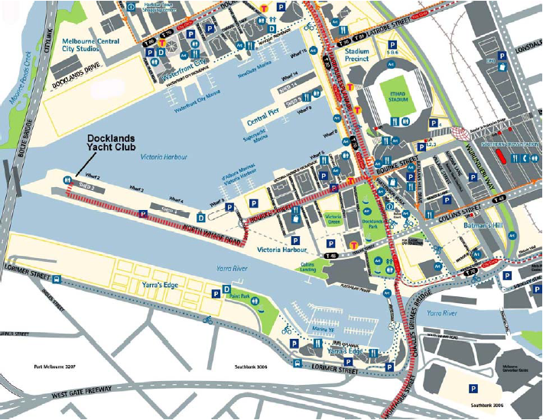

Docklands Yacht Club is located at the western end of Shed 2 on North Wharf Road, beside the disused Port Control Tower.

From South, East & Monash / Westgate Citylink – Travel north on Montague Street and take the left lane after crossing Lorimer Street to exit the Charles Grimes Bridge, proceed on to Harbour Esplanade, turn left at Bourke Street and proceed along the Bourke Street Extension, turn left at the roundabout, turn right at North Wharf Road.

From North & Inner West – Travel south on Harbour Esplanade (extension of Footscray Road), turn right at Bourke Street and proceed along the Bourke Street Extension, turn left at the roundabout, turn right at North Wharf Road.

Parking – If the parking booth is operational when you turn on to North Wharf Road (usually on days when there are sporting events at Etihad Stadium), advise the attendant you are going to Docklands Yacht Club and there will be no charge. If you park behind Shed 2, make sure you are not blocking any doorways. There is parking on the gravel area beyond Shed 2 on ‘the point’ or on the river side between Sheds 2 and 4. Parking on the dock on the Victoria Harbour side is discouraged.

